- Introduction

All chemical laboratories or other spaces with corrosives (acid or base), biological laboratories, battery maintenance areas, and pesticide mixing areas are required to have both a chemical safety shower and eyewash present. Showers require annual testing and eyewashes require weekly (no more than every 7 days) flushing at Virginia Tech. Eyewashes are not discussed further in this SOP.

This procedure outlines the preparation and testing steps for annual testing of all Virginia Tech emergency showers. This procedure is to be followed by Environmental Health and Safety personnel conducting the flow testing.

Note: Information about weekly eyewash flushing is provided on the EHS Website as part of the Chemical Hygiene Plan information: Eyewash Stations and Deluge Showers.

- Shower Testing Planning/Preparation

- The University Chemical Hygiene Officer or designee will meet with the Facilities Buildings Grounds and Trades Supervisors (See Appendix A) about a month prior to initiating the annual testing to establish a general schedule and obtain an updated Preventive Maintenance (PM) contact list.
- Each year, about a month prior to testing, EHS personnel shall review the condition of the shower testing curtain and purchase one or two new units as needed.

- Shower Testing Supplies

- The following supplies are needed for shower testing:
- shower testing curtain(s) – stored in MMF Base Room
- buckets (preferably with wheels) with five gallon marks – stored in MMF Base Room
- absorbent pads (for drips/spills) – stored in MMF
- clipboard
- stopwatch or other timing device
- all necessary tags (See Appendix A) - Maintained by CHO
- scissors/utility knife (for tag removal)
- zip-ties for tags as needed
- Student assistants should wear name badges to identify them as EHS representatives when entering labs. Badges are made internal to EHS.

- Scheduling

- EHS will contact Facilities Buildings Grounds and Trades Supervisors (See Appendix A) daily, or as needed, to schedule the preventative maintenance (PM) worker(s) needed to assist with testing at a given building. A specific meeting place and time will also be determined and communicated to student assistants and PM representatives. PM personnel are always required to be present during testing.
- EHS personnel should print out record sheets from the Emergency Shower Testing Workbook file for the buildings to be tested in a given day or take a fully charged electronic device with Excel to enter data directly.
  - See T:\EHSSOffice\Laboratory Safety Division\Programs\Laboratory Safety\Emergency ShowersEyewashes
- Daily, the University CHO will notify students of the showers to be visited the next day so they can prepare the data sheets and supplies.
- EHS personnel will go to the key shop in the Sterrett Facility Complex and request the necessary keys for the testing. Keys must be returned to the key shop the same day – do not keep overnight.
- EHS personnel will meet the preventative maintenance worker at the correct building to begin testing showers.

- Visual Inspection of Emergency Shower
The following items should be observed at each shower prior to the flow test. Record any deficiencies on the record sheets.
- Observe for any corrosion, leaks or pipe damage prior to turning the emergency shower on.
- Confirm that no electrical equipment or hazards are near the shower. If they are present, do not test and communicate to lab personnel to submit a work order (to have assessed). If chairs, trash cans or other equipment on wheel, student assistants may move these items out of the way.
- Ensure there is a clear path of travel to the emergency shower and that the shower area itself is unobstructed.
- Check that the shower is clearly identified and located with a visible sign and Virginia Tech EHS shower number. If any of these items are not present, or a new shower is being tested for the first time, provide EHS shower number or sign.
- Document if any of the conditions above are not met or if any other compromising issues are present.

- Shower Flow Rate Test/Retest

- IMPORTANT: Before the shower is tested, ensure that the PM representative knows the location of the emergency shut off valve in case the shower fails to turn off (to avoid a flood!). The preventative maintenance worker must be present to turn off the emergency valve or turn the main water line off in the instance of a valve failure.
- Set up the safety shower curtain and bucket so that the water will be contained when the shower is turned on.
- Turn on the shower (pull handle or chain, or handle for wall-mounted showers), when the water first reaches the bottom of the bucket, start the stopwatch. When the bucket fills to the five-gallon mark, stop stopwatch and turn off the shower. If the shower does not shut off, the emergency shut off valve should be employed.
  - Preventive Maintenance representative is there to assist.
- Use the Conversion Chart in the Appendix C to determine the flow rate. If no chart is available, use the following simplified calculation:
300/seconds to fill 5 gallons = Gallons Per Minute (GPM)
- Based on the determined flow rate for the shower, either update the tag on the shower or assign a new one based on the calculated gallons per minute. See Appendix B for images and descriptions of the shower tags.
  - Actual tag files are currently maintained on: T:\EHSSOffice\Laboratory Safety Division\Programs\Laboratory Safety\Emergency ShowersEyewashes
- Record the flow rate on the shower testing tag.
- Document the fill rate, gallons per minute, date tested and any necessary comments pertaining to the shower on the paper data sheet or directly on an electronic device (in Excel).
- EHS shower testing data is retained at T:\EHSSOffice\Laboratory Safety Division\Programs\Laboratory Safety\Emergency ShowersEyewashes. A google drive may also be used to manage the data when the student assistants are testing showers.
- Clean up any water that may have spilled and locate a sink or drain to dump the water from the bucket.
- Be sure to leave the area dry and in the same condition as encountered.

- Shower Inspection Standards

- All showers will be tested annually to the 20 gallon per minute standard set by the American National Standards institute (ANSI) and the Virginia plumbing code.
- Older buildings, which were not subject to the 20 gpm requirement when showers were installed, must be reviewed by the department and EHS if showers fail to meet the 20 gpm requirement.
- If there is an older building present in which 20 gpm cannot be achieved without significant costs, different options will be explored to determine a resolution.

- New Shower Flow Rate Testing

- When new showers are installed, the flow rate must be verified to meet the 20 gallon per minute requirement during commissioning prior to the occupancy of the newly constructed or renovated space.
- EHS will not test showers in new buildings or renovated spaces the first year.

Appendix A Facilities Scheduling Contacts
Al Sanders
Email: asanders@vt.edu
Work: 540-231-9922 Cell: 540-315-5253
Preventative Maintenance Supervisor
FS - Buildings Grounds and Trades

Bill Ross
Email: wross@vt.edu
Work: 540-231-3069 Cell: 540-315-2136
Trades/Utilities Master Mechanic
FS - Buildings Grounds and Trades
Appendix B Tags

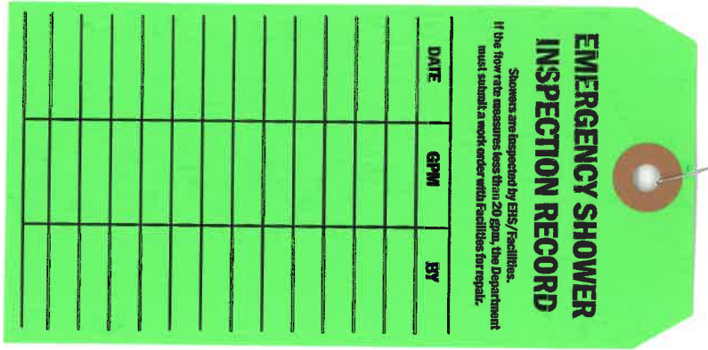  A green shower tag, denoting that the shower has passed the 20 gallon per minute standard. | 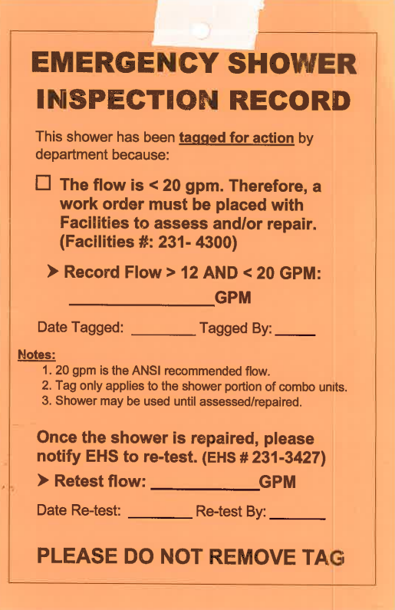  An orange low flow shower tag, denoting that the shower tested between 12 and 20 gallons per minute and is recommended for assessment.
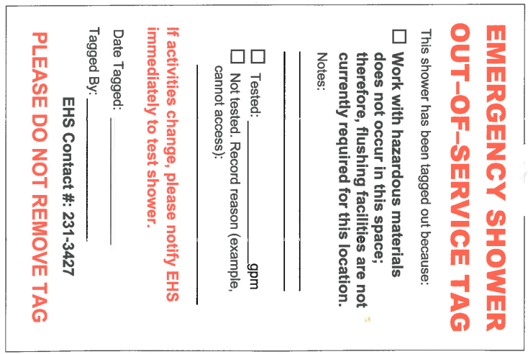  An emergency shower out-of-service tag. These tag outs are placed on showers in areas where there is no ongoing chemical use and they have been deemed as not needed. | 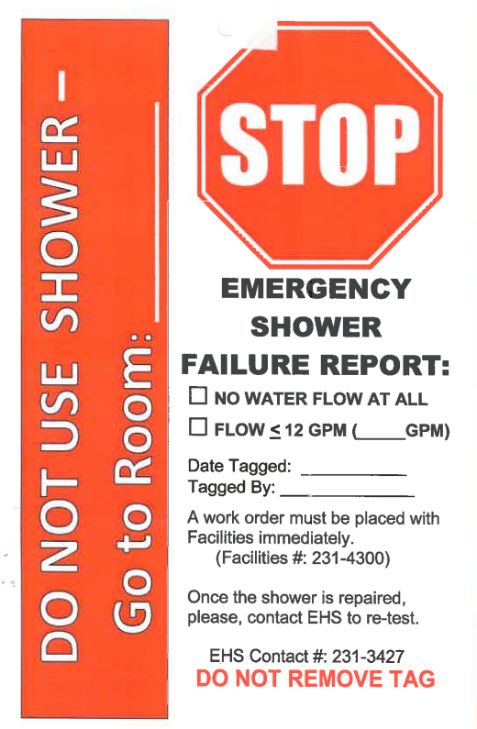  An emergency shower failure tag. These tags are placed on showers testing below or at 12 gallons a minute and need to be reviewed for repair.

Appendix C Flow Calculation Sheet

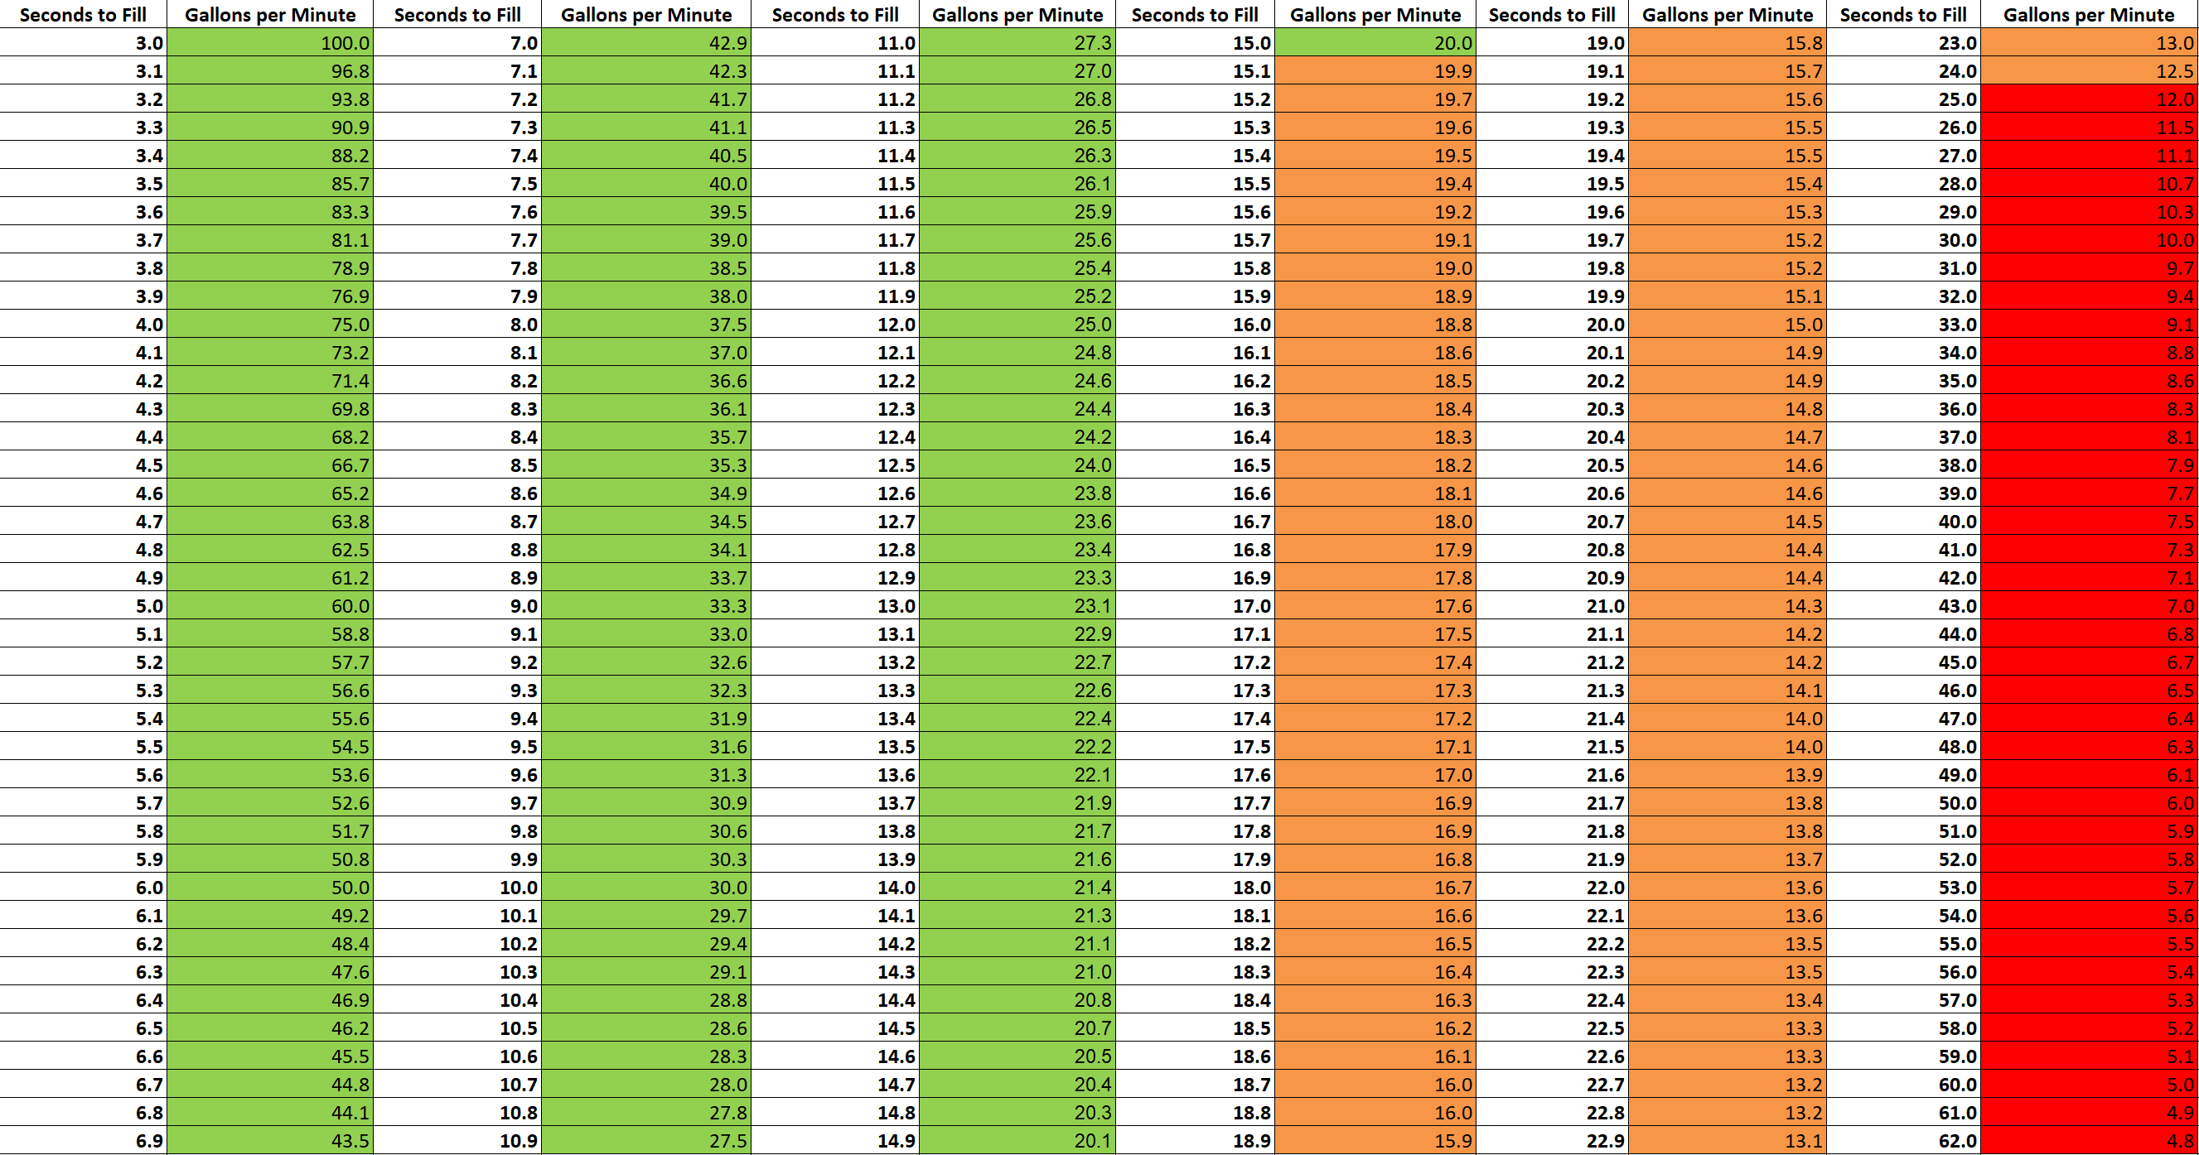
Formula sheet utilized to determine the calculated flow rates for the emergency safety showers. The seconds to fill column refers to seconds to fill bucket to 5-gallon mark. Simplified calculation to use if no chart available: 300/seconds to fill to 5 gallons=GPM

